**Check and compare DTD, XML Schema, Relax NG and other schema languages for XML.**

* 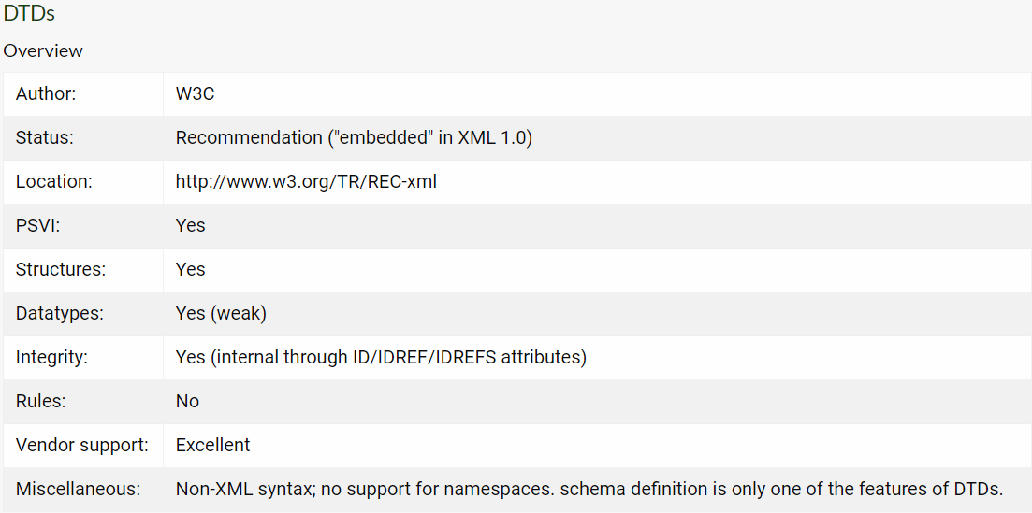**Overview:**

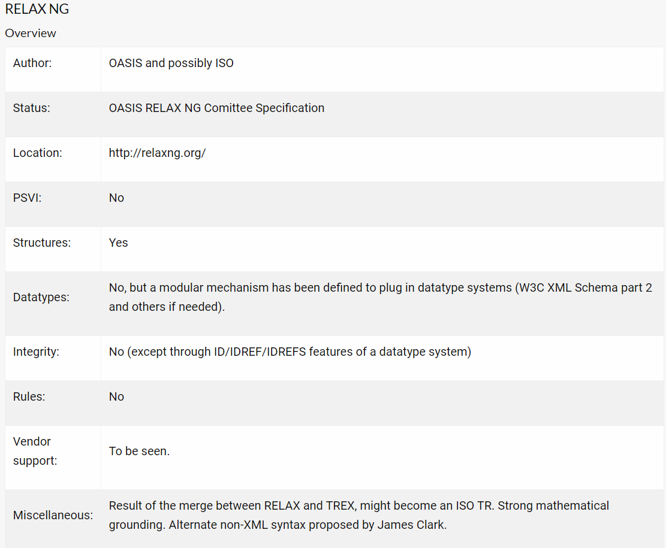

* **Compare XML Schema and DTD:**
* XML schemas are written in XML while DTD are derived from SGML syntax.
* XML schemas define datatypes for elements and attributes while DTD doesn't support datatypes.
* XML schemas allow support for namespaces while DTD does not.
* XML schemas define number and order of child elements, while DTD does not.
* XML schemas can be manipulated on your own with XML DOM but it is not possible in case of DTD.
* using XML schema user need not to learn a new language but working with DTD is difficult for a user.
* XML schema provides secure data communication i.e sender can describe the data in a way that receiver will understand, but in case of DTD data can be misunderstood by the receiver.
* XML schemas are extensible while DTD is not extensible.
* **Summary:**

**Tool support** (as of today)

1. Best: DTD
2. Most promising: W3C XML Schema
3. Challenger: RELAX NG
4. Niche: Schematron and Examplotron

**Features**

1. Structures: DTD, W3C XML Schema, RELAX NG, Examplotron.
2. Datatype: W3C XML Schema
3. Integrity: W3C XML Schema, Schematron, Examplotron
4. Rules: Schematron, Examplotron

**Flexibility** (ability to describe a wide range of structures)

1. Most flexible: Schematron (but everything needs to be defined "by hand").
2. Most flexible structure-based language: RELAX NG.
3. Integrity: W3C XML Schema, Schematron, Examplotron
4. Challenger: Examplotron
5. Behind: W3C XML Schema